DATA SCIENCE AND PROGRAMMING

Table of Contents
Tasks 3
References 10

Tasks
M1: there are two datasets one is “Sp_epitopes” and another one is “proteins”. In those datasets there are multiple attributes epitope_id, protein_id, epit_seq etc. and in the protein dataset there are some attributes which of those attributes have to join in a single dataset.
M2: In this task the attributes from Sp_epitopes and protein dataset have been joined in a new dataset adequately.
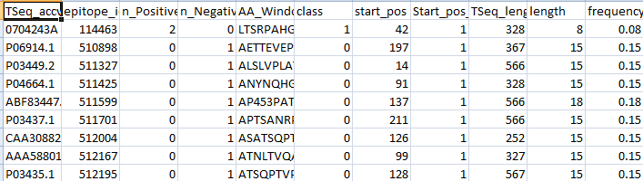
Figure 1: Dataset creation
(Source: Excel)
M3: In this task the invalid observations have been removed from new dataset and the modification on the dataset has been done (Rao et al. 2018).
M4: The class attributes have been calculated with the help of the n_Positive and n_negative in the csv dataset which have been created for the analysis.
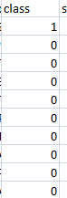
Figure 2: Class Attribute Creation
(Source: Excel)
M5: The visualization has been done on the dataset using the python programming language. In the visualization the class balance (Kery et al. 2018), epitope lengths and a bar chart of the frequencies of the letter of each amino acid have been shown.

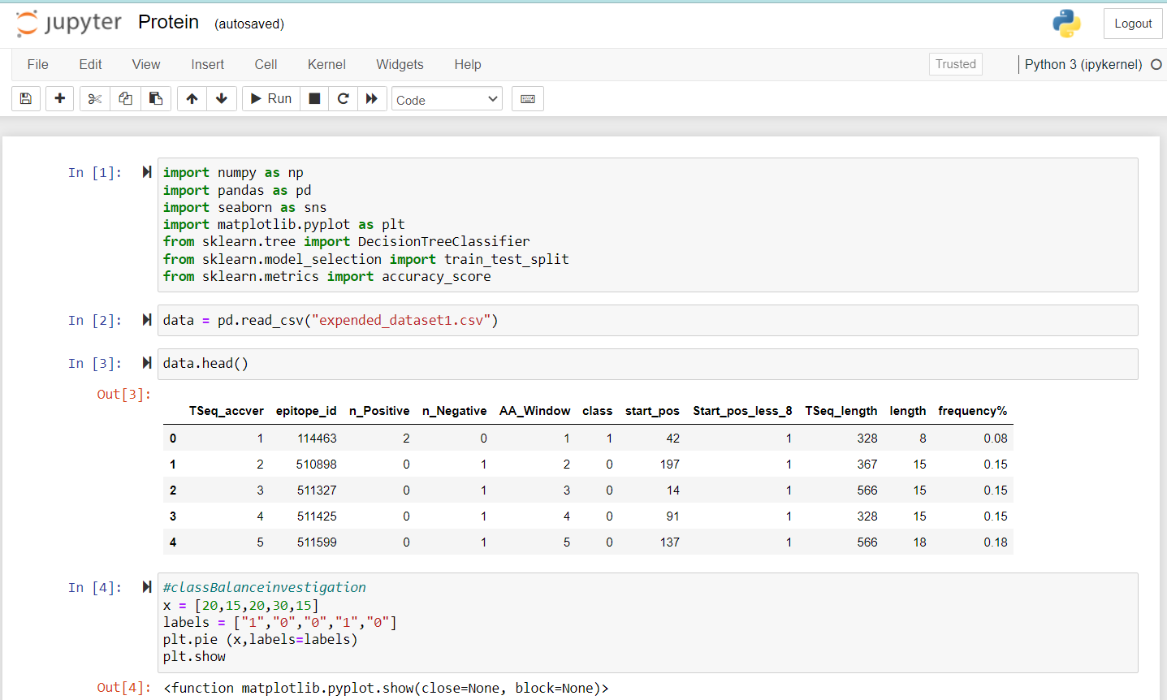
Figure 3: Dataset Importing in Python tool
(Source: Jupyter Notebook)
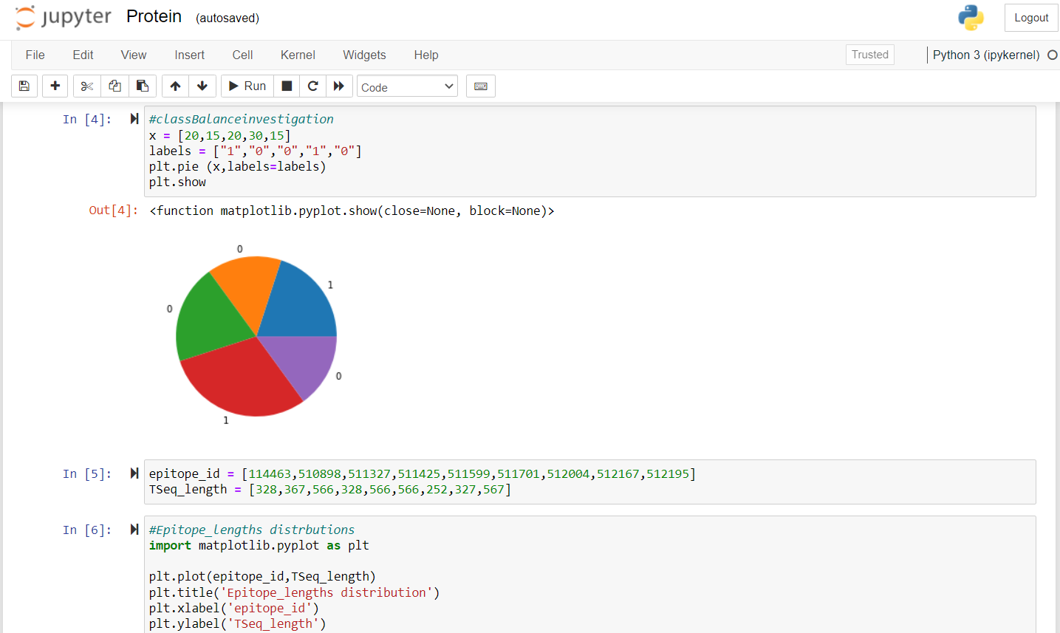
Figure 4: Dataset Visualization
(Source: Jupyter Notebook)
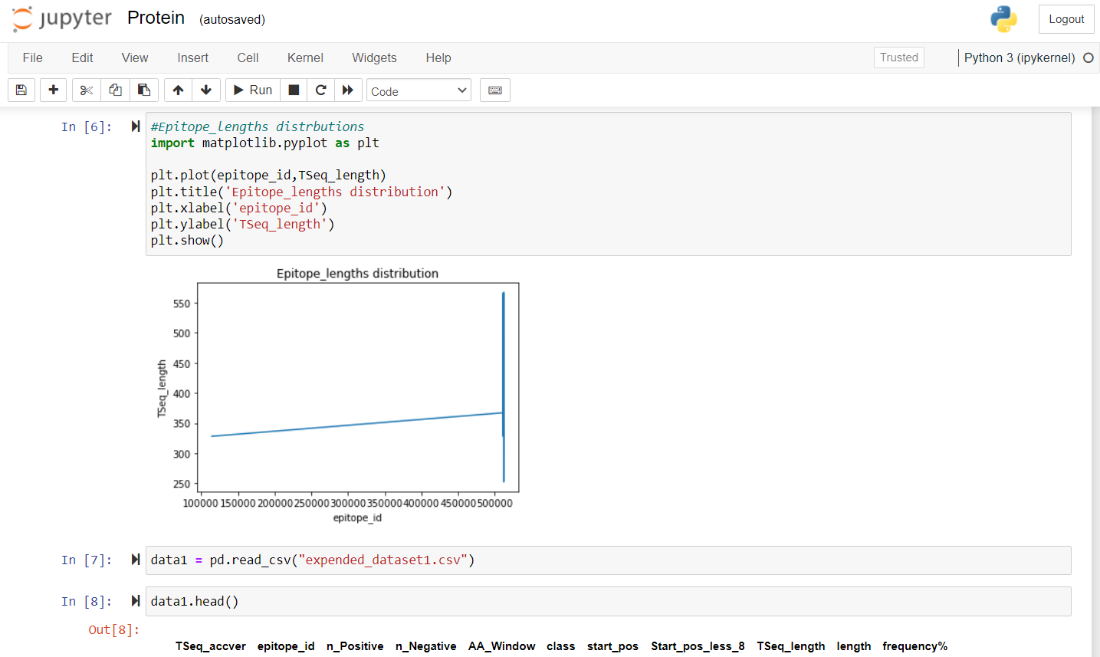
Figure 5: Dataset Visualization
(Source: Jupyter Notebook)
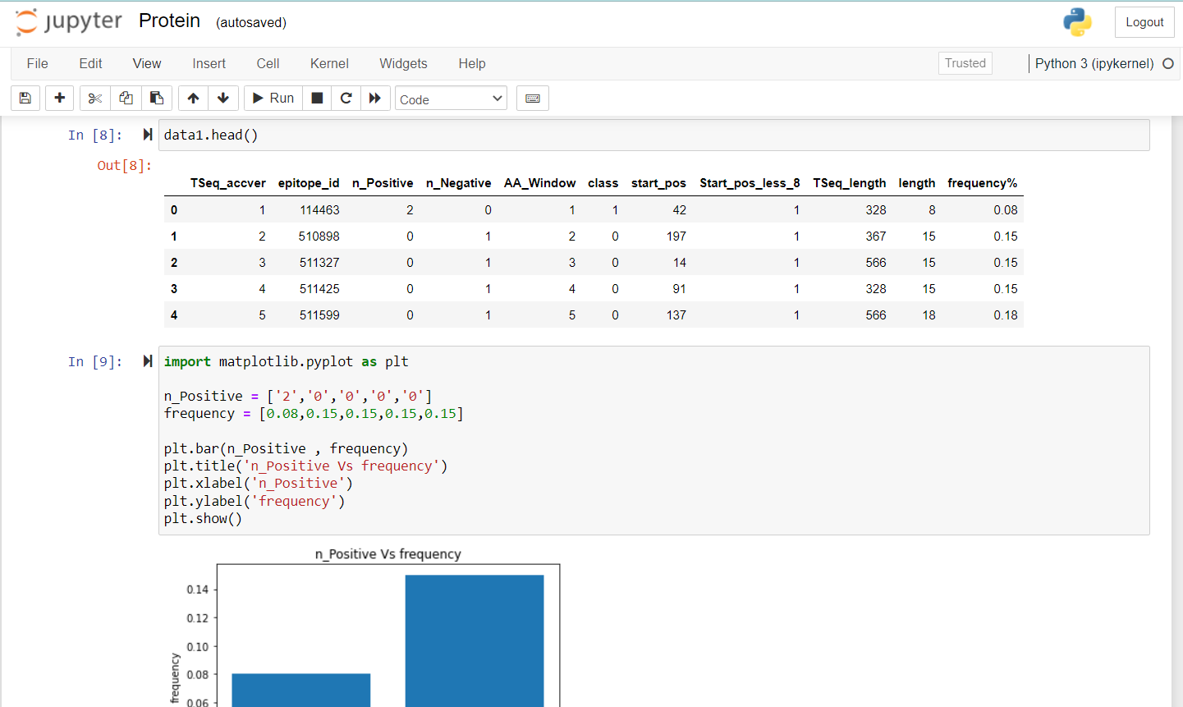
Figure 6: Dataset Visualization
(Source: Jupyter Notebook)
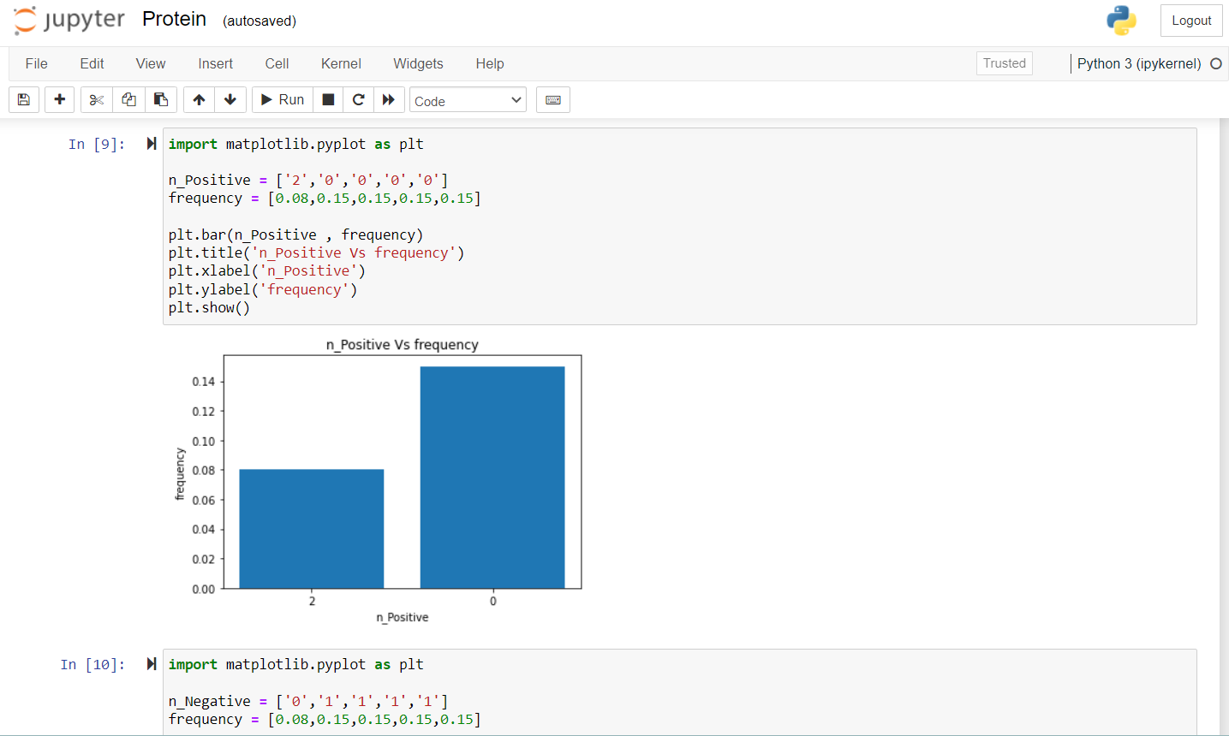
Figure 7: Dataset Visualization
(Source: Jupyter Notebook)
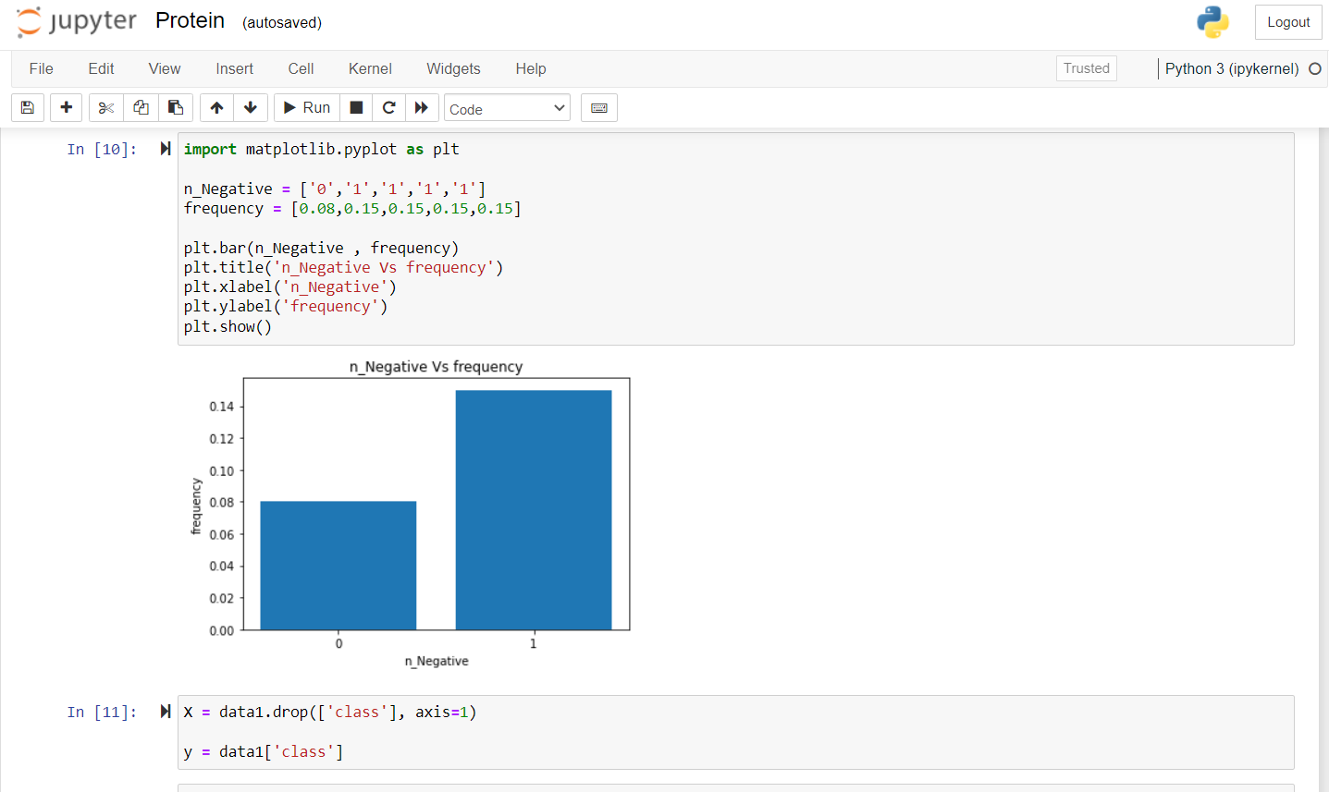
Figure 8: Dataset Visualization
(Source: Jupyter Notebook)
M6: In this section a dataset has been created with the name of “expanded data set” with the word of the task from M1 to M4.
S1: The imbalance of the class has been kept in between the dataset of extended dataset.
S2: Frequency of each individual letter has been calculated in this task.
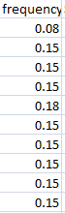
Figure 9: Frequency measurement of the Letter
(Source: Ms Excel)
S3: The splitting of the dataset has been done using the python programming language.

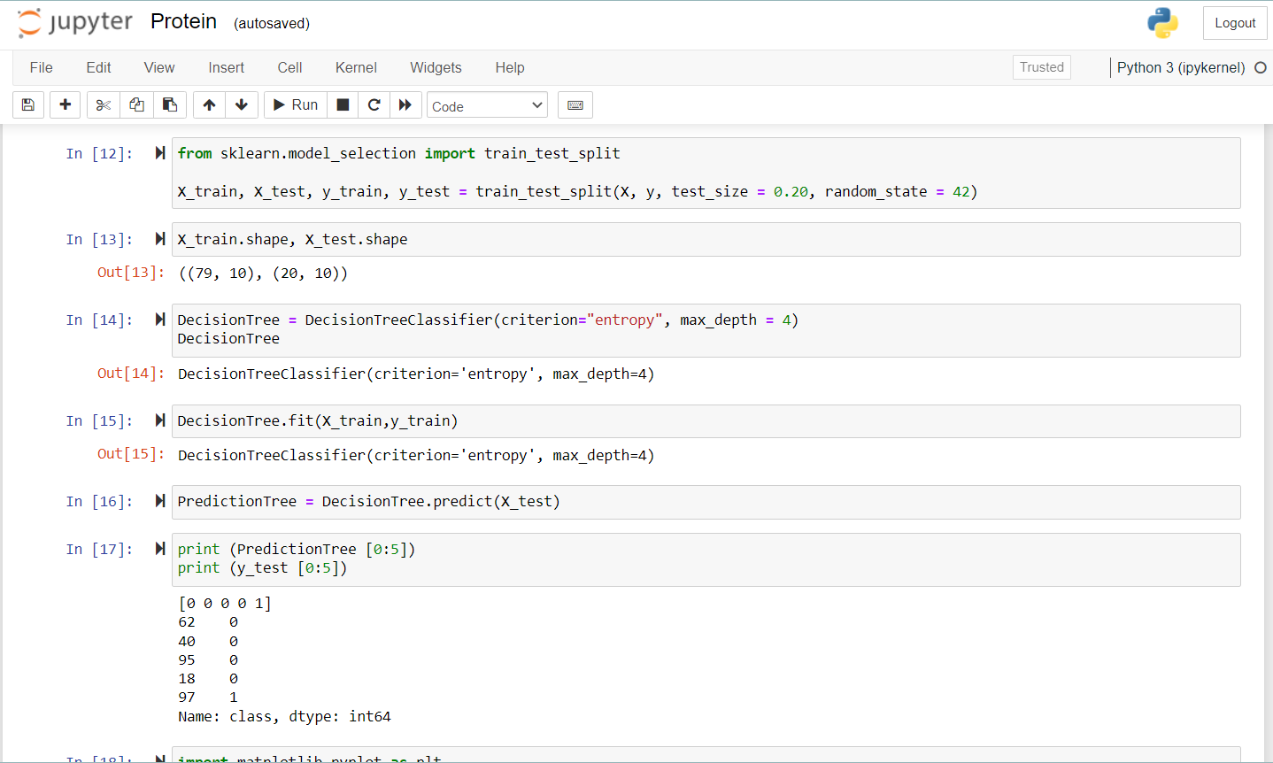
Figure 10: Dataset Splitting
(Source: Jupyter Notebook)
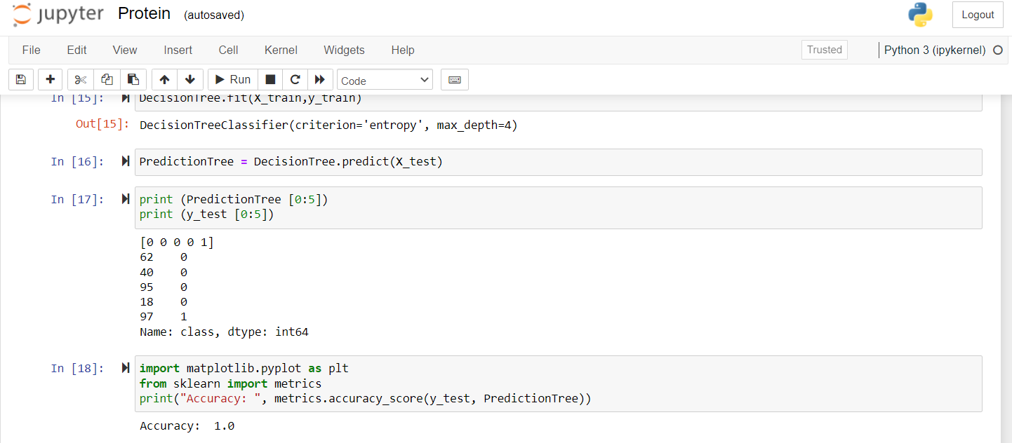
Figure 11: Dataset Splitting
(Source: Jupyter Notebook)

S4: A classification model has been fitted in the dataset using the python programming language.
C1: The TMM value as well as the value of MHI has been calculated in the dataset using the molecular mass and with the hydropath index accordingly.
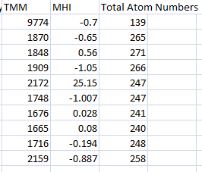
Figure 12: TMM, MHI and Total Atom Number
(Source: Excel)
C2: In the C2 task the visualization has been shown on the outcome of the value of C1 tasks.
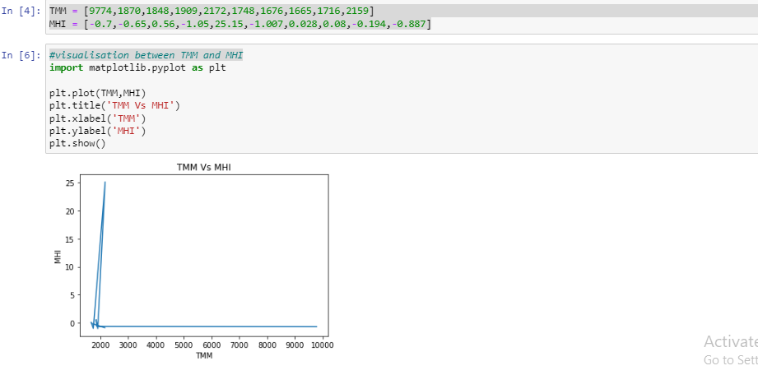
Figure 13: Dataset Visualization with TMM and MHI
(Source: Jupyter Notebook)

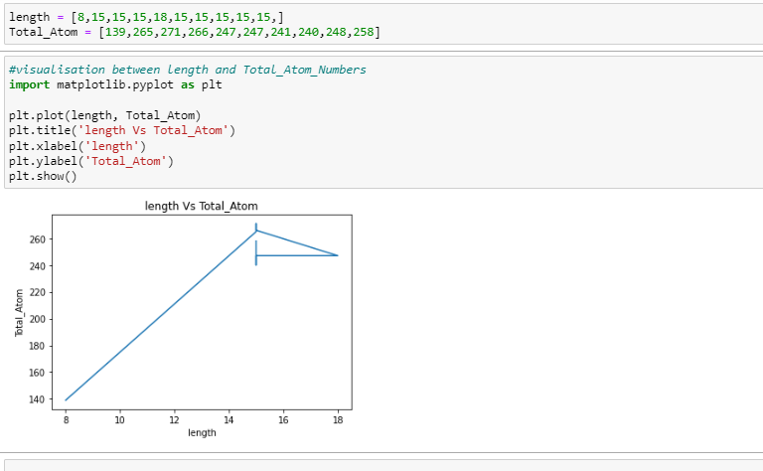
Figure 14: Dataset Visualization with total atom
(Source: Jupyter Notebook)

References
Journals
Kery, M.B., Radensky, M., Arya, M., John, B.E. and Myers, B.A., 2018, April. The story in the notebook: Exploratory data science using a literate programming tool. In Proceedings of the 2018 CHI Conference on Human Factors in Computing Systems (pp. 1-11).
Rao, A., Bihani, A. and Nair, M., 2018, October. Milo: A visual programming environment for data science education. In 2018 IEEE Symposium on Visual Languages and Human-Centric Computing (VL/HCC) (pp. 211-215). IEEE.

